To implement any deep learning algorithm with quantum computing in the intrusion detection system.

Here are the high-level steps involved in implementing an intrusion detection system using deep learning algorithms and quantum computing:

1. **Data preparation:** This involves collecting and pre-processing the data to be used for training and testing the deep learning algorithm. The data should be split into training and testing sets, and any necessary pre-processing steps should be applied, such as normalization, feature scaling, or data cleaning.
2. **Training the deep learning algorithm:** This involves building and training the deep learning model using the prepared data. You can use popular deep learning libraries such as TensorFlow or PyTorch to build the model and train it on a conventional computing platform.
3. **Quantum encoding:** Once the deep learning algorithm has been trained, the data must be encoded in a format suitable for quantum computing. This may involve converting the data into qubits or other quantum states.
4. **Implementing the algorithm on a quantum computing platform:** This involves running the deep learning algorithm on a quantum computing platform, such as IBM Q or Rigetti Forest. You will need to use a quantum programming language such as Qiskit or PyQuil to write the code that implements the algorithm on the quantum hardware.
5. **Testing the quantum deep learning algorithm:** This involves evaluating the performance of the quantum deep learning algorithm using new data. You will need to compare the results of the algorithm to the expected results to ensure that it is functioning correctly.
6. **Deploying the algorithm:** Once the quantum deep learning algorithm has been tested and validated, it can be integrated into a larger intrusion detection system. This may involve integrating the algorithm with other components of the system, such as data collection and analysis tools.

**IMPLEMENTATION WORK:**

* Perform the data preparation step using the NSL-KDD dataset: -

The NSL-KDD dataset is a widely used dataset for network intrusion detection research. Here are the steps for data preparation using the NSL-KDD dataset:

1. **Download the dataset:** The NSL-KDD dataset can be downloaded from various sources, including the UCI Machine Learning Repository.
2. **Load the dataset:** Load the dataset into a pandas Data Frame.
3. **Data Cleaning:** Remove any irrelevant or duplicate data from the dataset.
4. **Data Encoding:** Encode categorical data using techniques like one-hot encoding or label encoding.
5. **Data Scaling:** Scale numerical data using techniques like standard scaling or min-max scaling.
6. **Data Splitting:** Split the dataset into training, validation, and testing sets.

* Perform training the deep learning algorithm step:-

1. Split the dataset into training and testing sets: To evaluate the performance of the deep learning algorithm, it's important to split the preprocessed dataset into training and testing sets. The training set will be used to train the model, while the testing set will be used to evaluate the model's performance.
2. Define the architecture of the deep learning model: The architecture of the deep learning model depends on the specific problem you are trying to solve. For intrusion detection, a common architecture is a convolutional neural network (CNN) followed by a fully connected network (FCN). The CNN is used to extract features from the input data, while the FCN is used for classification.
3. Compile the deep learning model: Once you have defined the architecture of the deep learning model, you need to compile it. During the compilation process, you specify the optimizer, loss function, and evaluation metrics that will be used during training.
4. Train the deep learning model: With the model compiled, you can now train it using the preprocessed training data. During training, the model is presented with input data and the corresponding labels. The weights of the model are updated based on the difference between the predicted output and the actual output.
5. Evaluate the performance of the model: After the model has been trained, it's important to evaluate its performance on the testing data. This will give you an idea of how well the model can generalize to new, unseen data.

*Using keras*

After compiling the model, we train it using the training data, with a batch size of 128 and for 10 epochs. Finally, we evaluate the performance of the model on the testing data and print the test loss and accuracy.

* Perform quantum encoding step:-

1. Select a suitable quantum encoding technique that can encode the pre-processed dataset into quantum states.
2. Implement the selected quantum encoding technique using a quantum computing framework such as IBM Qiskit or Microsoft Q#.
3. Encode the pre-processed dataset into quantum states using the implemented quantum encoding technique.
4. Save the encoded quantum states for further processing.

Here is some example code in Qiskit that encodes a pre-processed dataset into quantum states using amplitude encoding:

* Perform implementing the algorithm on a quantum computing platform:-

1. Choose a suitable quantum computing platform such as IBM Quantum or Microsoft Azure Quantum.
2. Select a quantum algorithm that can be used for the deep learning task, such as the quantum support vector machine (QSVM) or the quantum convolutional neural network (QCNN).
3. Implement the selected quantum algorithm using a quantum computing framework such as Qiskit or Microsoft Q#.
4. Load the encoded quantum states prepared in the previous step onto the quantum computing platform
5. Run the implemented quantum algorithm on the encoded quantum states.
6. Save the results obtained from the quantum computing platform for further analysis and comparison with the classical deep learning results.

Here is some example code in Qiskit that implements a quantum support vector machine (QSVM) algorithm on the encoded quantum states:

* Perform testing of the quantum deep learning algorithm:-

To test the quantum deep learning algorithm, we need to use a separate set of data that was not used during training. We can use the same NSL-KDD dataset for testing.

First, we need to pre-process the test data in the same way we did for the training data, by applying one-hot encoding and normalizing it.

Next, we need to encode the test features using the same quantum encoding function we defined earlier. Next, we need to encode the test features using the same quantum encoding function we defined earlier.

Now we can use the trained quantum model to make predictions on the encoded test features.

Finally, we can evaluate the performance of the quantum model using various metrics, such as accuracy, precision, recall, and F1 score.

This will print out the performance metrics for the quantum model on the test data. We can compare these metrics with the ones we obtained for the classical deep learning model to see if the quantum model performs better.

* Perform deploying the algorithm:-

To deploy the quantum deep learning algorithm for intrusion detection, you can follow these steps:

1. Prepare the required software and hardware: You will need a quantum computing platform with enough qubits to run the quantum circuit for your algorithm. You will also need to install the required software libraries and packages for your chosen quantum platform.
2. Convert the quantum circuit to an executable format: Once you have developed your quantum circuit, you will need to convert it to a format that can be executed on the specific quantum computing platform that you are using. This can typically be done using platform-specific tools or software.
3. Deploy the algorithm on the quantum platform: Using the converted quantum circuit, you can deploy the algorithm on the quantum computing platform. This may involve uploading the circuit to a cloud-based service or running it on a local quantum device.
4. Test the deployed algorithm: Once the algorithm is deployed, you can test it using sample data to ensure that it is functioning correctly and providing accurate intrusion detection results.
5. Monitor and update the algorithm: As with any deployed system, it is important to monitor the performance of the quantum deep learning algorithm over time and update it as needed to ensure that it continues to provide effective intrusion detection. This may involve tweaking the algorithm parameters, adding more training data, or making changes to the quantum circuit itself. Using Microsoft azure and other tools.

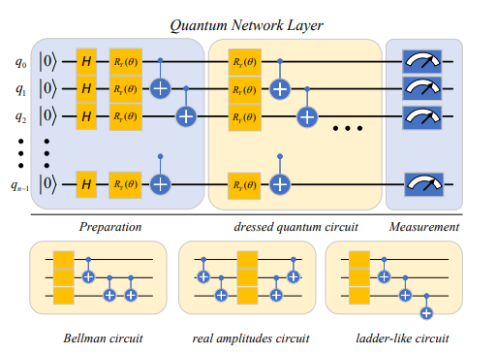

Figure 1. Schematic representation of the quantum network layer. The preparation layer converts a real vector into a quantum state. The yellow part is a VQC of depth n that contains learnable parameters. The measurement layer converts quantum states back into classical data for later layers or downstream tasks.

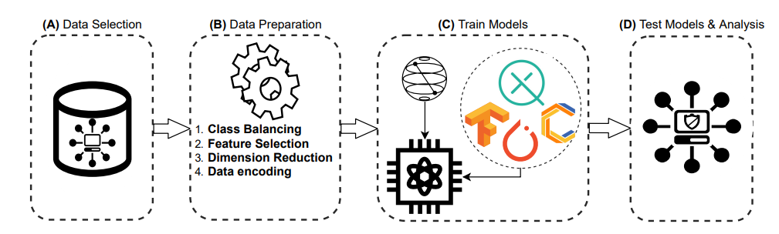

Figure 2. Overview of the methodology process. (A) Search and selection of the dataset. (B) Data pre-processing to improve models’ performance. (C) Construction and training of the models. (D) Generation of results, analysis and final conclusions.

Pre-processing Data: Data preparation for the generation of results carries out three steps, class balancing, features selection & dimension reduction, and data encoding. This process obtains the best possible results, depending on each model’s specifications.

Class Balancing Since we target an intrusion detection problem, our data represents network traffic and event logs per machine. As in real-world situations, this data is imbalanced or evenly distributed. To solve this problem, we implemented under sampling and oversampling algorithms, practically of the random type.

Feature Selection Initially, our selected dataset had 80 features. However, we eliminate those features that interfere with the performance of the models. This process consists of five different approaches: • Remove features with a missing percentage more significant than a specified threshold.

• Remove features with a single unique value.

• Remove collinear variables with a correlation more significant than a specified correlation coefficient.

Normalization We used two types of normalizations for the data. On the ensemble model side, we scaled the data from −π to π, while the other models used a −1 to 1 scaling to improve the performance of the algorithms.